Zone of Light Studio
Request for Donation
1174 Zonolite Place NE
Atlanta, Georgia 30306
678-948-8059
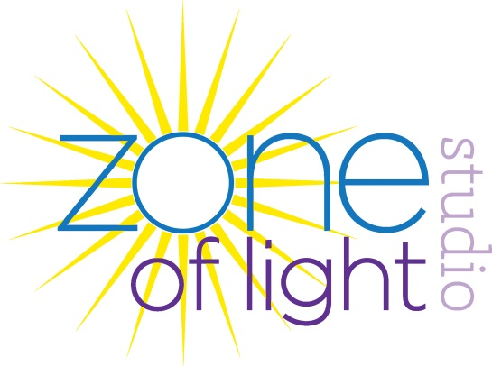

Please email completed donation request to Amy Wilson at awilson@zoneoflightstudio.com
Name of Organization |  | Date:
Address
Person requesting donation
Phone Number
Email Address
EIN/TIN number of school or nonprofit organization
Code Section of organization (IE: 501c3, schools 403b)
Designation of donation
Contact person for donation
Method of selecting recipient (state event if it is a silent auction.)
Money collected from donation is to be used for
Estimated value of donation
Submit signed and completed form to: Amy W. Wilson (Founder, Zone of Light Studio)
awilson@zoneoflightstudio.com * 678-948-8059
Date Accepted: _______________
Signature of contact person: _______________________________________
Role of Contact Person: ________________________________________

